**ArcGIS Pro, Python, ArcPy, Pandas, and COD Services API a GIS How To Mashup**

The following shows which country locations have COD or Common Operational Dataset representation in an ArcGIS Pro session. The COD Services API allows for a concise real-time listing of countries available for humanitarian mapping and analysis use. It is very helpful to show these areas on the map using ArcGIS Pro with Notebook, scripting and mapping capabilities.

Steps:

1. Start ArcGIS Pro:

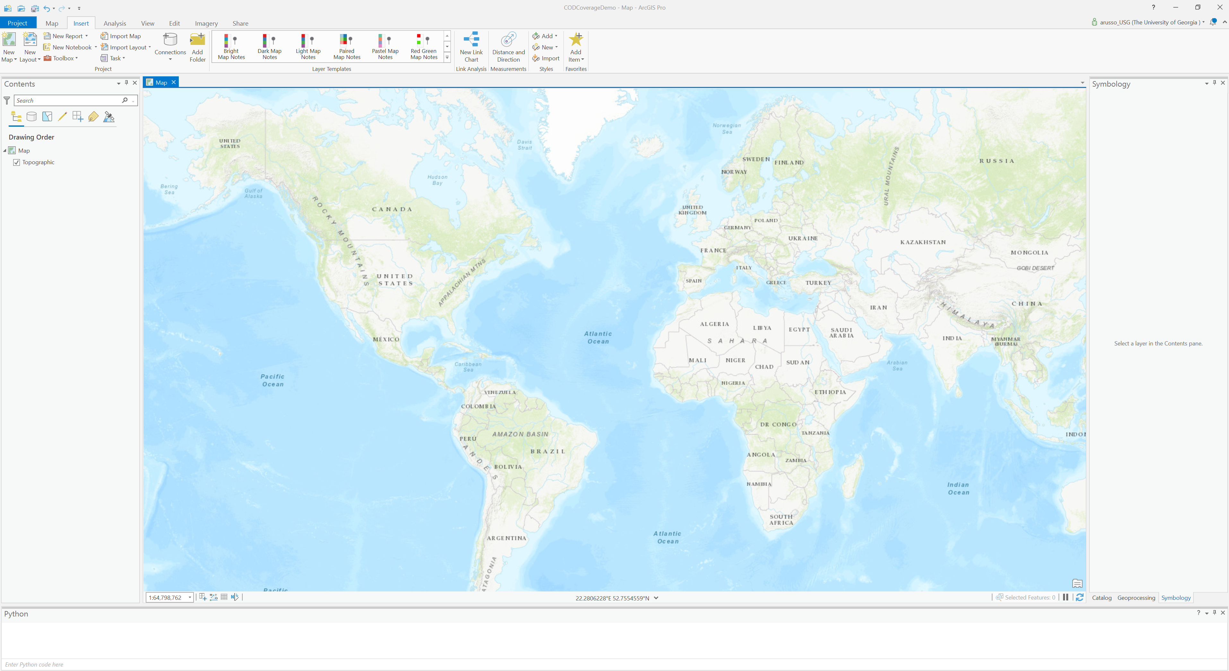

1. Download (<https://data.fieldmaps.io/edge-matched/humanitarian/intl/adm1_polygons.shp.zip>) the Global Edge-Matched Layer (credits to Max Malynowsky and Fieldmaps.io for the work bringing disparate sources together to create a global boundaries layer that may be used for these and similar purposes). Note that the UN Geo Hub is the reference for an UN source that is used for other processes including global edge-matched datasets.
2. Unzip the shapefile and copy the layer to your local machine for instance, at C:\WorkSpace.
3. Add the layer to the map. This is typically done through the ArcGIS Pro set of menus and tabs as shown:

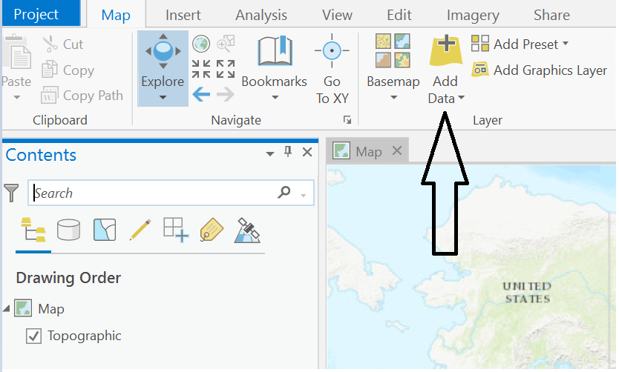

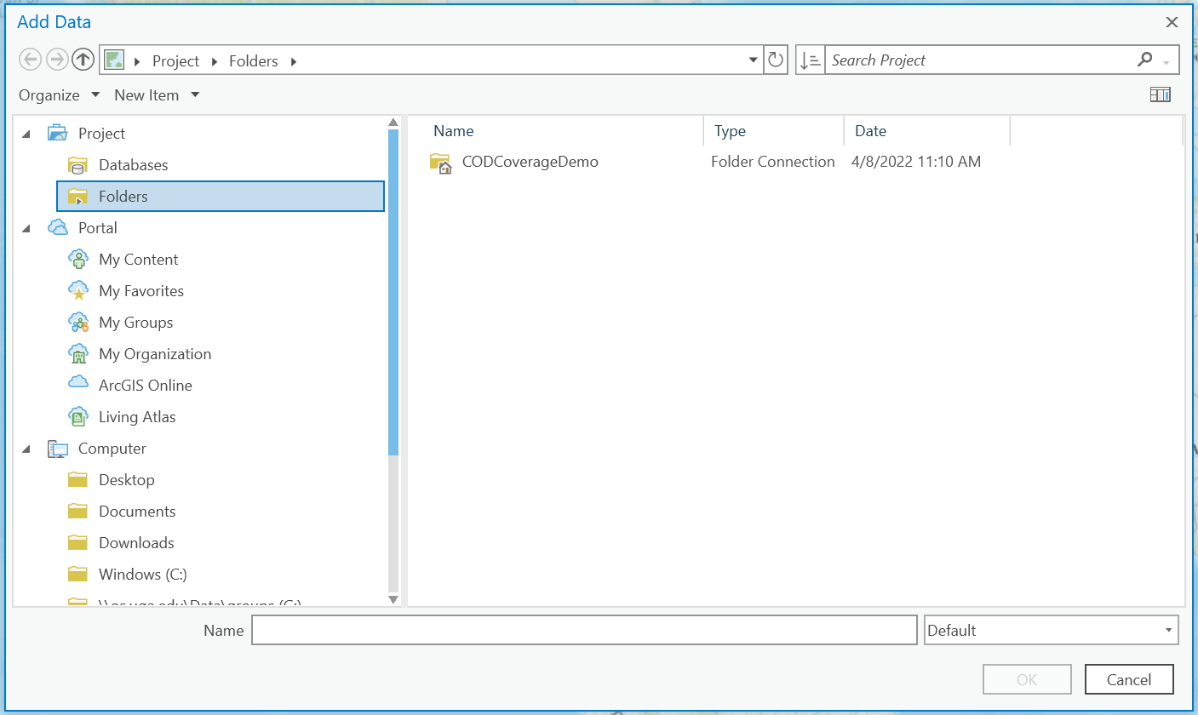

Alternatively, you can add the layer to the map using a notebook. Launch the notebook environment directly within the ArcGIS Pro session by clicking on the Insert tab. This shows the New Notebook option.

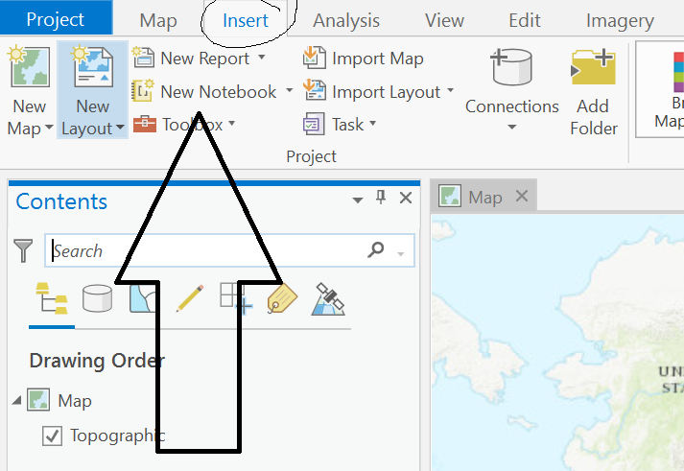

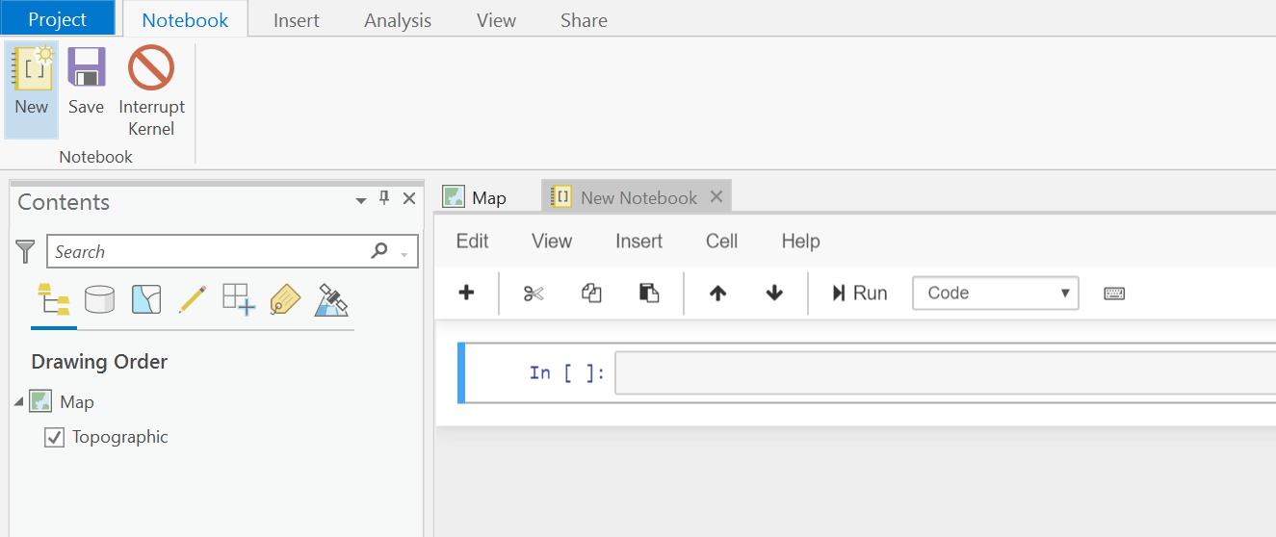

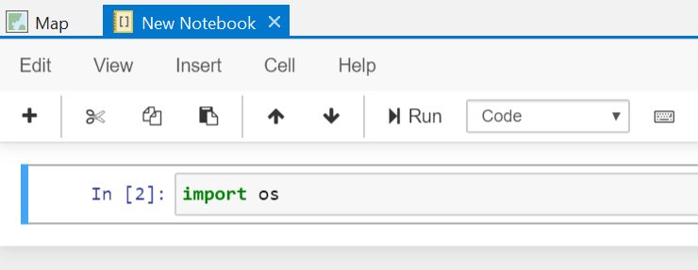

If you are new to notebook work, note that the workspace consists of a cell approach to entering statements and blocks of statements. Ctrl + Enter will execute the current cell’s statements. The number in brackets, 2 shown, will increment as the same cell’s code is executed. You can start another cell with the “plus” icon button. This approach allows for more incremental approach to coding, while still allowing for entire scripts to run in one cell. In this first statement example, import os, the operation loads a library that makes other statements for accessing files (like the downloaded shapefile) on the local machine workable. There will be other similar imports through this exercise. In some cases, there may be the need to install packages and then to import their libraries to make them available, however, these should not be needed here. More on installing external libraries are found here: https://pro.arcgis.com/en/pro-app/2.8/arcpy/get-started/work-with-python-packages.htm.

So in the next few images, the code is expanded with additional statements in the cells to load the global boundaries shapefile that will define the countries for the map geometry in this exercise.

Note that there is a means to make reference to the session and the map default topographic layer.

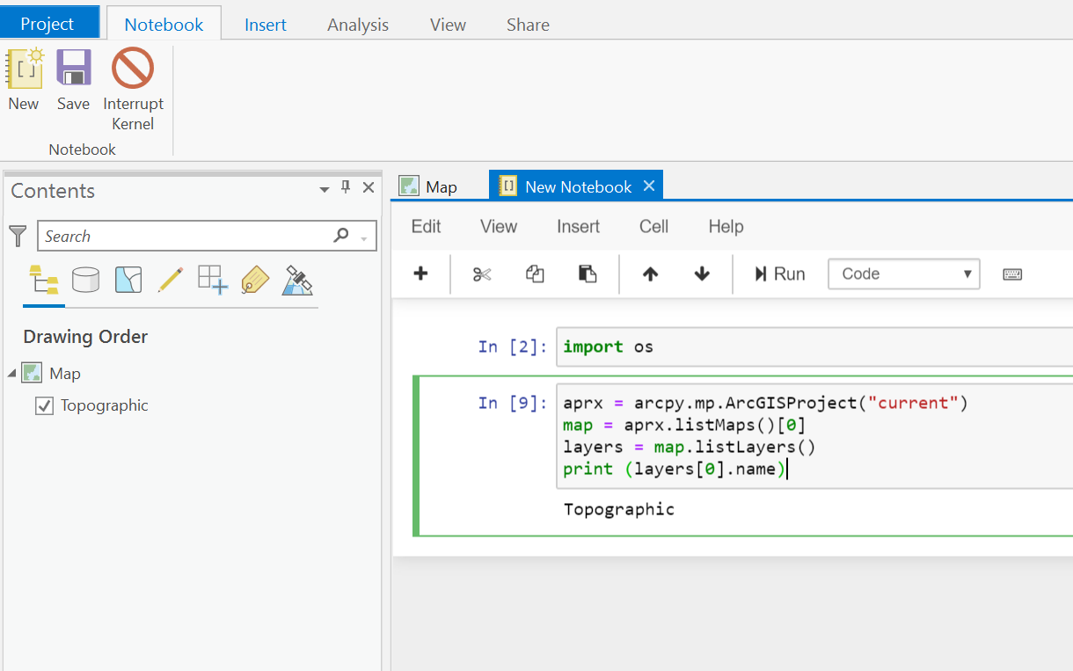

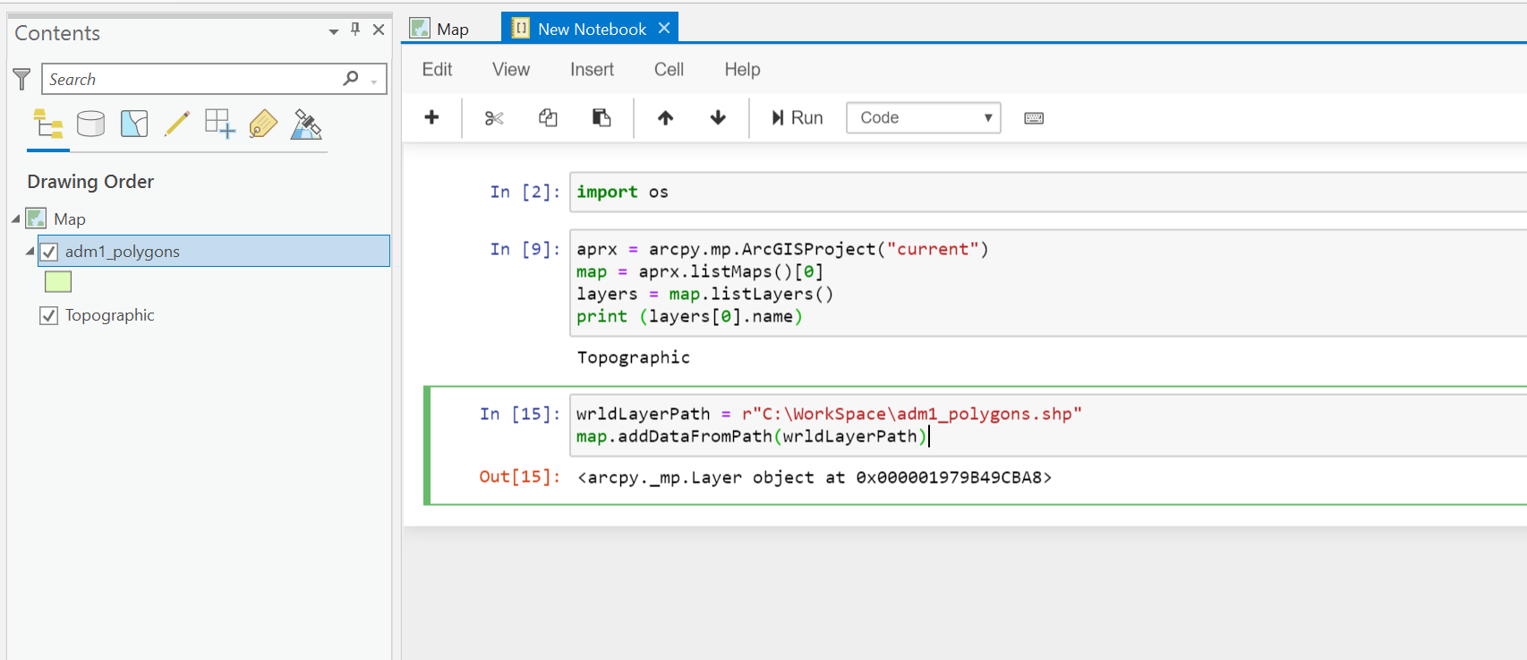

The cell that is at position three is the code that loads the new layer.

In a new cell, the COD Services API data may be loaded to show which countries have CODs. The url provided when invoked shows that there is a message that an additional library is needed.

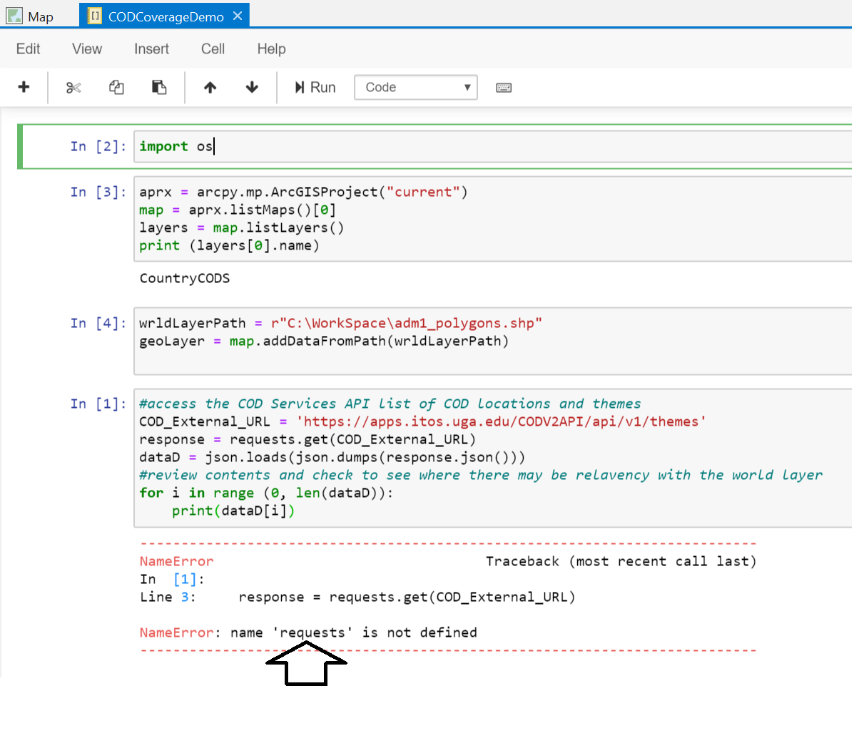

This is where we need an import. Note that we used the arcpy reference without one. That is because we are within an ArcGIS Pro session. The requests python function is also installed but it is not available to the session, so we will import it and add the line up in the first cell. Remember we have to run that, so enter Ctrl + Enter in the first cell after adding it. You can add import statements anywhere in code, they are typically added in the beginning for readibility and to organize the code flow in a readible fashion. Now I can go and run the last cell, and the error is no longer encountered:

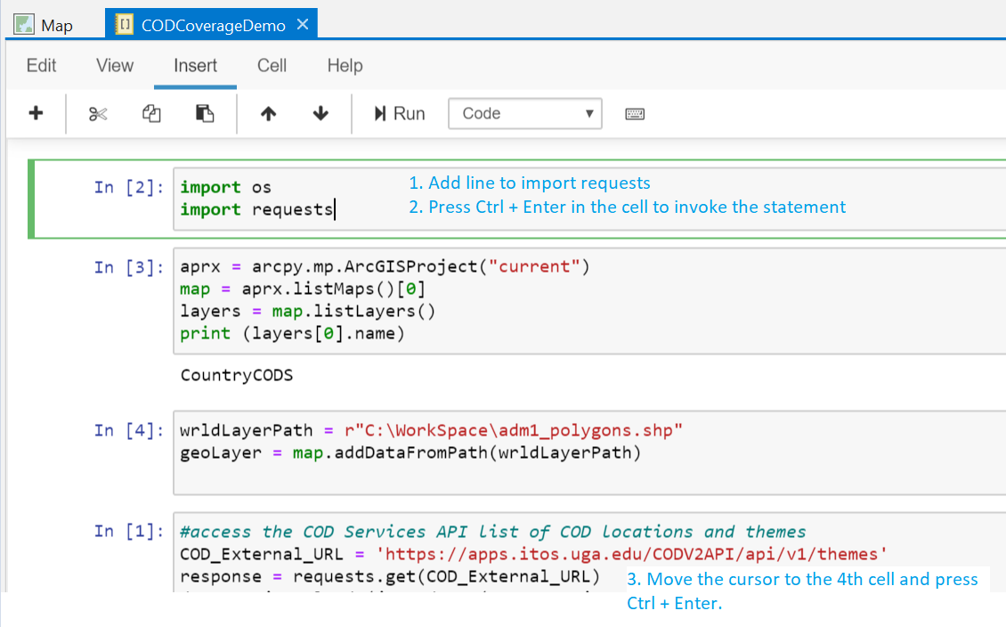

Now add a line in the first cell again to import json, run it and add the code to review the output of the COD Services API call. This way we can find where we may use the relevant relatable contents or attributes to show the results on the map. The context for the relationship between the two sources is the 3 character country ISO code.

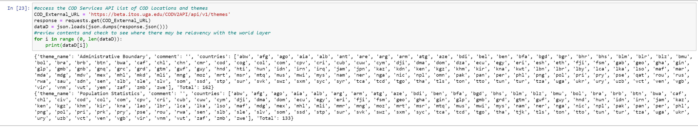

To review the layer table, right mouse click on the layer in the map contents to get the context menu, which includes the “Attribute table” command:

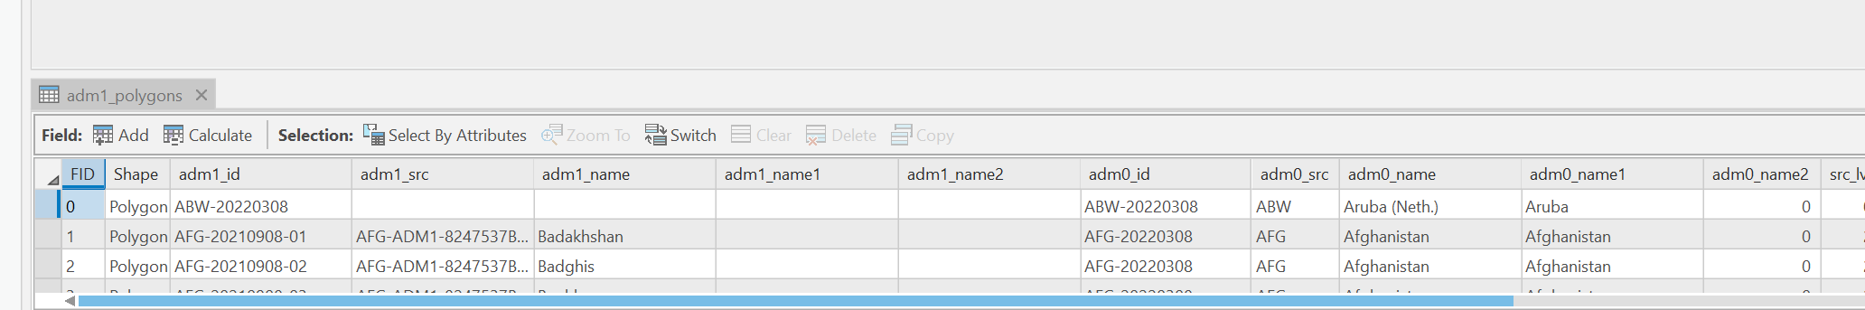

So, the results of the COD Services API themes call show listings of themes and countries and that the countries are listed according to theme using the 3 character ISO code. The geometry may be related to this based on the adm0_src contents according to the layer table, provided the letter case is updated to match. For this first example we are interested in seeing any location for which there is a COD on the map regardless of theme. In the next step, we will arrange the output to have the countries as rows to join to the geometry layer in the map. We will do this using Pandas libraries.

Add another import statement to the first cell using the as keyword for standardization purposes:

**Import pandas as pd**

Ctrl + Enter to invoke this.

In the last cell add the Pandas statements to arrange the output. There will be a long list now instead of two rows by theme, the data will now show with the country ISO as the row definition.

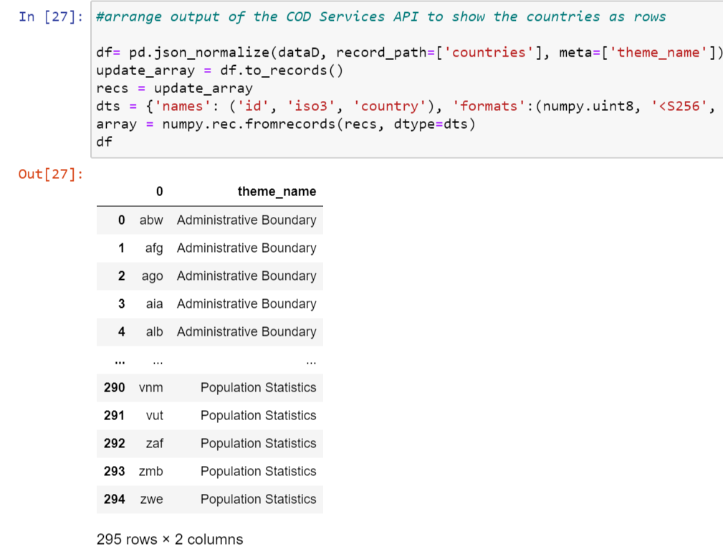

Once the output is upper case, the data can be joined to match up with the geometry in the world boundaries layer and shown on the map.

Add another cell, include the code and run with Ctrl + Enter

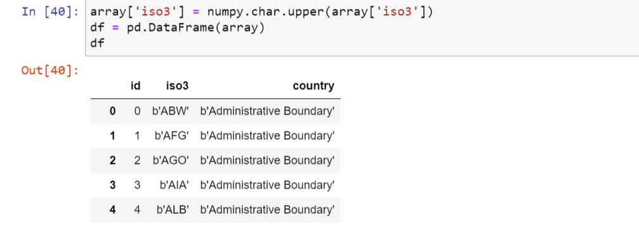

The upper-case output can now be added as a standalone table in the map. This step is necessary for the geometry layer join.

As we progress along the way, we can see how it is useful to work in this Notebook fashion, with groups of cells organizing code in manageable sections.

Updating the line in cell 5 allows for decoding of the ISO3

dts = {'names': ('id', 'iso3', 'country'), 'formats':(numpy.uint8, 'U13', '<S256')}

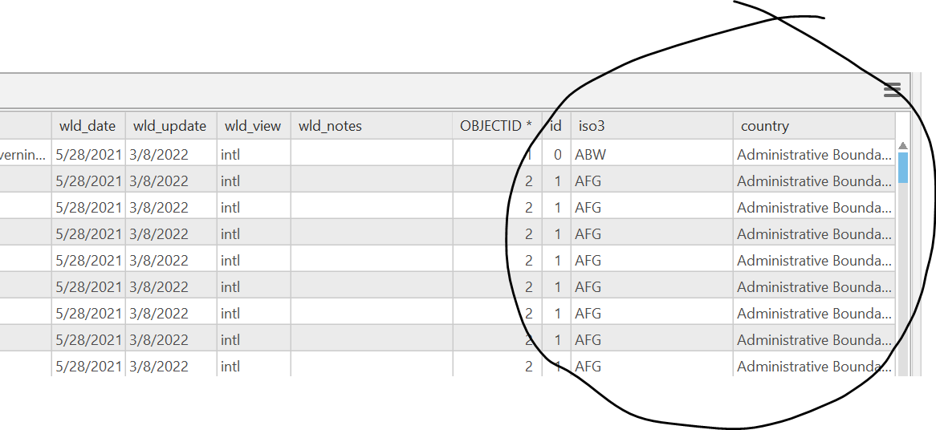

Scrolling down, we see some features do not have representation of iso3 and are shown as <Null>. These look to be in Northern Europe. Lets update the map to see more clearly.

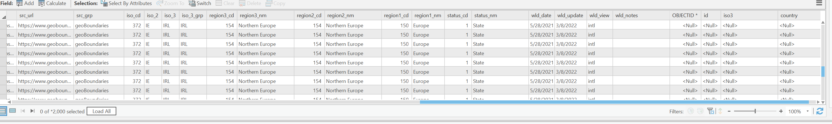

Symbolize based on the ISO3 values using the Unique Value Renderer:

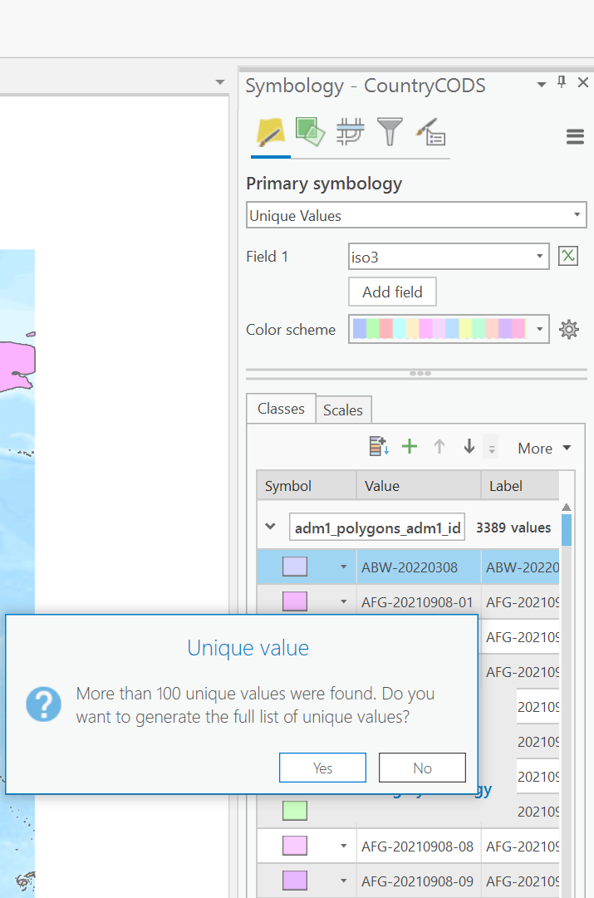

Areas that do not have corresponding values in the COD Services API are null and not matching the geometry. These were updated to show a symbol that is easily differentiated from the matching areas. The symbols render those areas based on the pattern whereas those areas that match are in pastel.

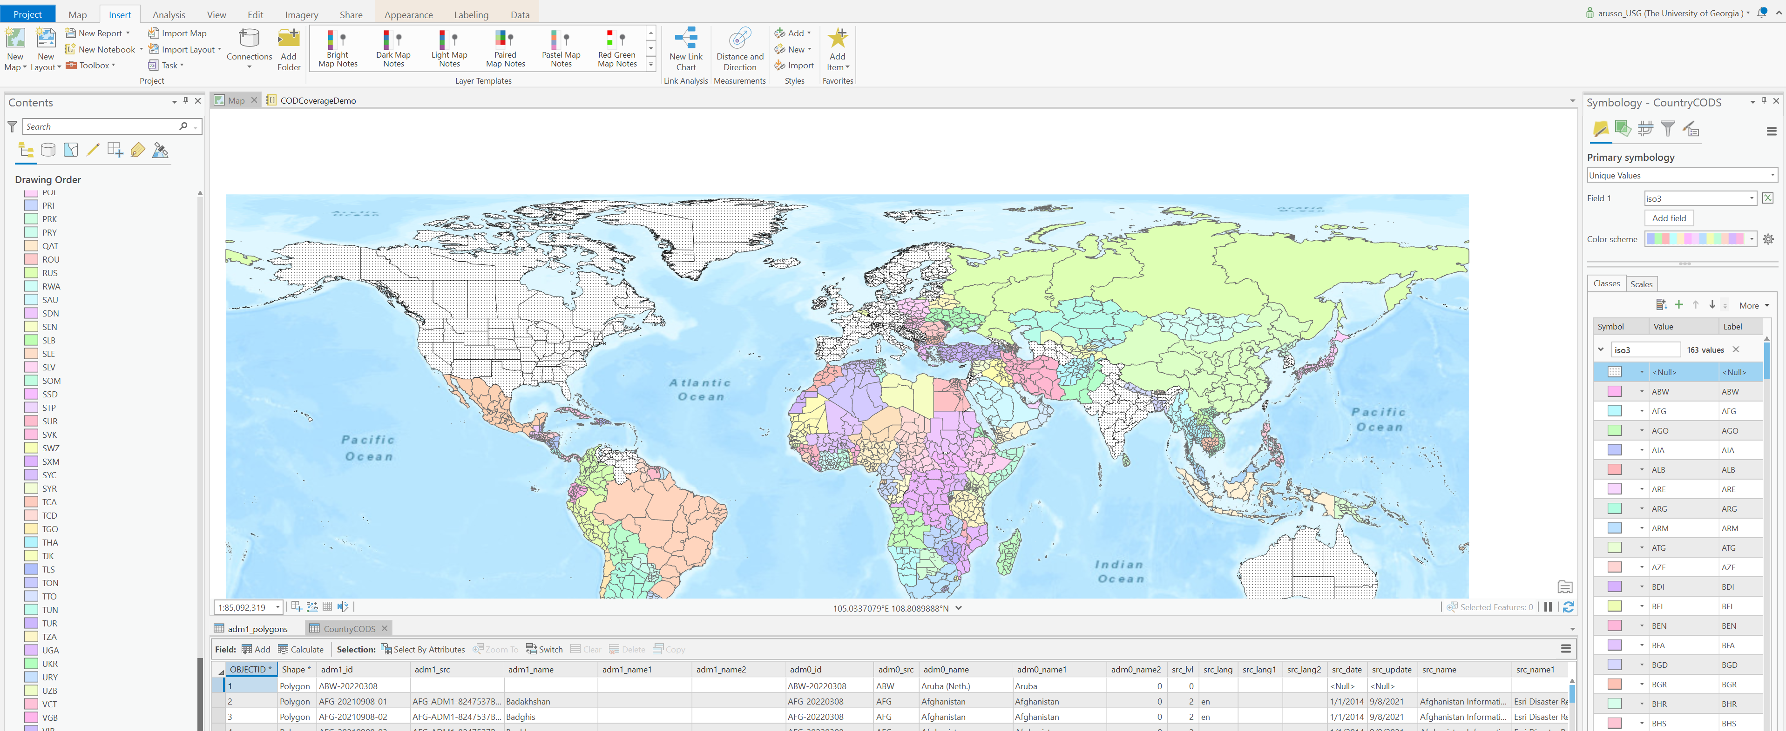

So the notebook approach makes for a flexible means to incorporate the data science environment conventions with the GIS layers. The COD Services API example shows how that this map may be updated with a real time result based on a system call rather than a static dataset.